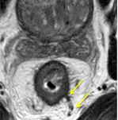
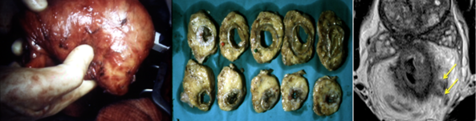
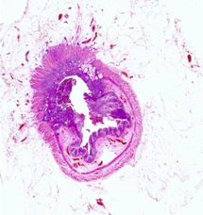
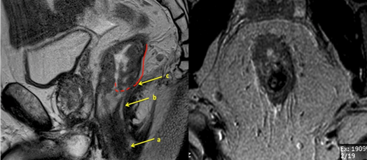


11th – 12th January, 2016
Pelvic MRI for the colorectal MDT
Anatomy, Staging and Decision Making: Interactive case-based learning and discussions in a two-day multidisciplinary workshop
Optimising MRI technique
Royal Society of Medicine  1 Wimpole Street  London W1G 0AE  MRI anatomy of the pelvis and pelvic floor  Audience:  Practising rectal cancer surgeons, radiologists and oncologists who wish to increase their understanding of MRI rectal cancer and anatomy of the pelvis.  How to assess: T stage, vascular invasion, nodes and the mesorectal margin  Indications for preop therapy and post treatment evaluation  Evaluating low rectal cancers and surgery beyond the TME plane  Aim:  By the end of the course delegates will be able identify the important anatomic landmarks and use MRI confidently to improve their pre-operative staging assessment and preoperative decision making.  Registration:  Early bird registration before 1st Nov 2015 £375  Registration from 1st Nov 2015 £450  Includes lunches and morning/afternoon refreshments for each delegate on both days.  Course Dinner:  We hope you will join us at the course dinner on Monday 15th January for the opportunity to relax and network with delegates and faculty. Each ticket costs £45 which includes 3 course meal and half a bottle of wine.  11 CPD points awarded  Capacity is limited so to guarantee your place, please complete the registration section of this flyer and return as soon as possible | FACULTY  Course Convenors  Professor Gina Brown  Professor Paris Tekkis  Mr Manish Chand  GUEST FACULTY  Professor RJ Heald  Professor J Nicholls  Mr B Moran  Mr C Cunningham  Mr T Arulampalam


Registration Form

Name:

Position:

Institution:

email:

Tel:

Address:

I wish to register for:

Pelvic MRI for the Colorectal MDT (£375 early bird / £450)
Two day course 11th, 12th January 2016

Course Dinner (£45)
11th January 2016

Please return registration form to Gina.Brown@rmh.nhs.uk or
Fax: + 44 (0) 208 915 6721

You will receive confirmation of your registration within 2 working days together with an invoice and instructions for payment.

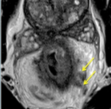
Please contact +44 (0) 20 8661 3964 if you have any queries

11th – 12th January, 2016
Pelvic MRI for the colorectal MDT

Day One

Prof. Gina Brown

Faculty Discussants: Prof. Bill Heald, Prof. John Nicholls

08:30 Registration and Coffee
09:00 Welcome and objectives
Session 1
Steps needed to ensure high quality MRI in your institution
Oncological and surgical anatomy of the pelvis – surgeons, radiologists and detailed road mapping for surgical and oncological planning
MRI assessment of early rectal cancer and treatment options based on MRI evaluation
Guide to assessment and decision making of low rectal cancers using MRI assessment
13:00 Lunch
Session 2
Accurate lymph node characterisation
How to recognise EMVI in rectal cancer and its clinical relevance
CRM threats at baseline and post treatment
19:00 Course Dinner
11th – 12th January, 2016
Pelvic MRI for the colorectal MDT

DAY TWO

Prof. Paris Tekkis Prof Gina Brown

Faculty Discussants: Mr Brendan Moran. Mr Chris Cunningham, Mr Tan Arularampalam

09:00 Coffee, Welcome and objectives
Session 3
Assessing response to treatment
How to identify complete response using MRI
Discussion of local excision / TME for early rectal cancer
MRI surveillance and deferral of surgery – tips and tricks
13:00 Lunch
Session 4
Beyond TME anastomotic considerations
Surgical management of CRM involved tumours – beyond TME strategies
Recognising and staging pelvic recurrences using MRI; surgical and non-surgical management and work up of pelvic recurrence.
MRI assessment of sigmoid cancer
Imaging and strategies for synchronous ulcerative disease.
16:00 Close

