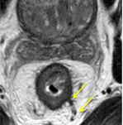
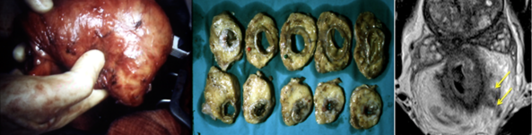
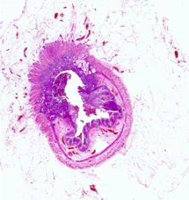
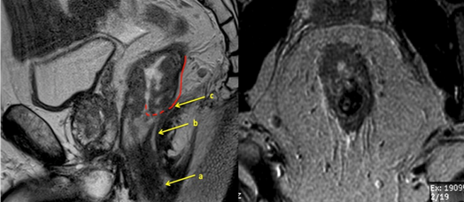

 12th – 13th January, 2017
Pelvic MRI for the colorectal MDT
Anatomy, Staging and Decision Making: Interactive case-based learning and discussions in a two-day multidisciplinary workshop
Royal Society of Medicine
1 Wimpole Street London W1G 0AE

Audience:
Optimising MRI technique
Practising rectal cancer surgeons, radiologists and oncologists who wish to increase their understanding of MRI rectal cancer and anatomy of the pelvis.
MRI anatomy of the pelvis and pelvic floor
Aim:
By the end of the course delegates will be able identify the important anatomic landmarks and use MRI confidently to improve their pre-operative staging assessment and preoperative decision making.
How to assess: T stage, vascular invasion, nodes and the mesorectal margin
Registration:
In order to fully benefit from a multidisciplinary audience, this year we have introduced a reduced MDT registration rate for two or more MDT colleagues attending.
Indications for preop therapy and post treatment evaluation
MDT registration:
Early bird registration before 1st Nov 2016 £375
Evaluating low rectal cancers and surgery beyond the TME plane
Registration from 1st Nov 2016 £450
Single registration:
Early bird registration before 1st Nov 2016 £450
FACULTY
Professor Gina Brown
Professor Paris Tekkis
INVITED FACULTY
Professor RJ Heald
Professor J Nicholls
Mr B Moran
Mr C Cunningham
Mr T Arulampalam
Dr A Kuzu
Dr D Tait
Registration from 1st Nov 2016 £500
Includes lunches and morning/afternoon refreshments for each delegate on both days.
Course Dinner:
We hope you will join us at the course dinner on Thursday 12th January for the opportunity to relax and network with delegates and faculty. Each ticket costs £55 which includes 3 course meal and half a bottle of wine.
11 CPD points awarded
Capacity is limited so to guarantee your place, please
complete the registration section of this flyer and return as soon as possible
Registration Form
Name:

Position:

Institution:

The information above will appear on your badge for the course

email:

Tel:

Address:

I wish to register for:

Single registration (£450 early bird / £500)
Two day course 12^{h}, 13th January 2017

MDT registration (£375 early bird / £450)
Two day course 12th, 13th January 2017
Colleague name:
Colleague email:

Course Dinner (£55)
12th January 2017

Please return registration form to Gina.Brown@rmh.nhs.uk or
Fax: + 44 (0) 208 915 6721

You will receive confirmation of your registration within 2 working days together with an invoice and instructions for payment.

Please contact +44 (0) 20 8661 3964 if you have any queries
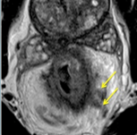

11th – 12th January, 2017
Pelvic MRI for the colorectal MDT

Day One

08:30 Registration and Coffee
09:00 Welcome and objectives
Session 1
BASICS
Steps needed to ensure high quality MRI in your institution
Clinical and cadaveric anatomy
Oncological and surgical anatomy of the pelvis – surgeons, radiologists and detailed road mapping for surgical and oncological planning
COLON CANCER ASSESSMENT
Colon assessment: implications for colonic resection
Vascular anatomy of colonic resection
CT anatomy – preoperative assessment of colon cancer

13:00 Lunch

Session 2
Staging assessment
T staging assessment
Accurate lymph node characterisation
EMVI in rectal cancer and its clinical relevance
Low rectal cancer staging and assessment
Surgical implications: ELAPE vs LAR?
Who should receive preoperative CRT?

19:00 Course Dinner
11th – 12th January, 2017
Pelvic MRI for the colorectal MDT

DAY TWO

09:00 Coffee, Welcome and objectives

Session 3
Discussion of local excision / TME for early rectal cancer
MRI surveillance and deferral of surgery – tips and tricks
Assessing response to treatment
How to identify complete response using MRI

13:00 Lunch

Session 4
Beyond TME anastomotic considerations
Surgical management of CRM involved tumours – beyond TME strategies
Recognising and staging pelvic recurrences using MRI; surgical and non-surgical management and work up of pelvic recurrence.
MRI assessment of sigmoid cancer
Imaging and strategies for synchronous metastatic disease.

16:00 Close

