**For more details, or to register, contact:**

[sophie.robb@uhnm.nhs.uk](mailto:sophie.robb@uhnm.nhs.uk)

[holly.woolliscroft@uhnm.nhs.uk](mailto:holly.woolliscroft@uhnm.nhs.uk)

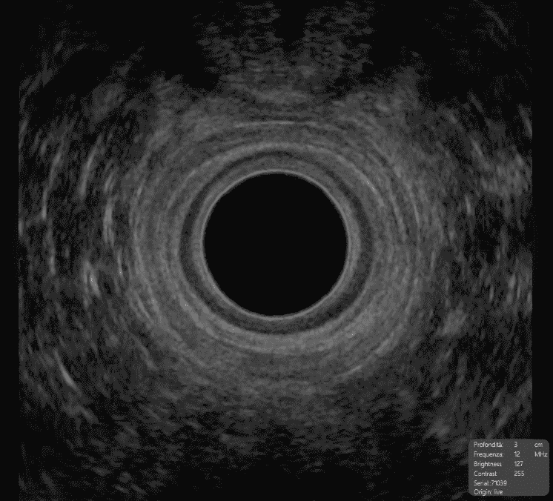

**UHNM PELVIC**

**FLOOR IMAGING**

**WORKSHOP**

**15th and 16th January 2026**

**A comprehensive study event focused**

**on imaging of the pelvic floor**

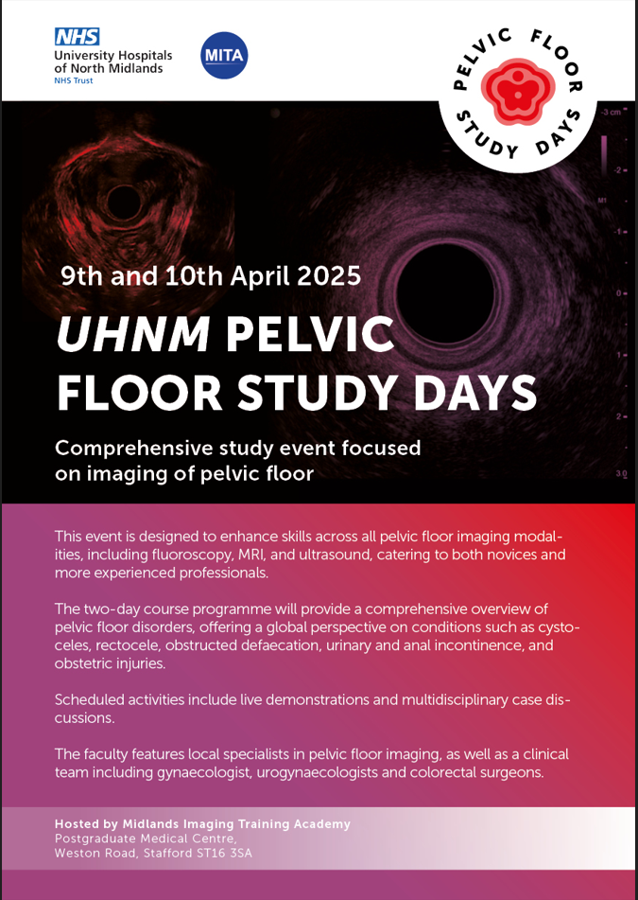

This event is designed to enhance skills across all pelvic floor imaging modalities, including fluoroscopy, MRI and ultrasound, catering to both novices and more experienced professionals.

The two-day course programme will provide a comprehensive overview of pelvic floor disorders, such as cystoceles, rectocele, obstructed defaecation, urinary and anal incontinence and obstetric injuries. The event also presents an ideal opportunity to network with other pelvic floor professionals.

Scheduled activities include case demonstrations, expert presentations and multidisciplinary discussions.

The faculty features local specialists in pelvic floor imaging, as well as a clinical team including gynaecologists, urogynaecologists and colorectal surgeons.

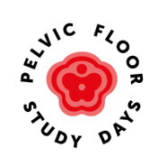

**Hosted by Midlands Imaging Training Academy**

Postgraduate Medical Cente,

Weston Road, Stafford ST16 3SA

**Hosted by Midlands Imaging Training Academy**

Postgraduate Medical Centre,

Weston Road, Stafford ST16 3SA