Guideline for inserting template in CRIS

To use the template on CRIS, it needs to be stored as a “Short-phrase”/autotext, with an assigned “phrase-code”. It would be best to store sections A-C (for initial staging only) and section D (for post neoadjuvent scans only) separately using two different phrase codes (e.g. “panc” and “pancpost”).

In order for text formatting to appear on CRIS, text formatting tags (~B/~b for bold, ~U / ~u for underline and ~I / ~i for italics) needs to be used. Moreover, the “Tab” key to align the texts does not work on CRIS - multiple spaces need to be entered using the spacebar to simulate a “Tab”.

Two separate CRIS versions of the pancreatic cancer reporting templates have been produced with all the relevant formatting tags and spaces needed for it to appear as intended on CRIS (“PACT-UK - Initial staging (CRIS version)” & “PACT-UK - Post neoadj (CRIS version)”). The text formatting will not work if simply copied and pasted directly into CRIS. The local IT team / CRIS team need to first store the templates as a “Short-phrase”/autotext on CRIS and assign a “phrase-code” (e.g. “panc”). This can then be automatically inserted in any report by typing the phrase-code followed by “Alt-P” command - the correctly formatted template will then be inserted.

Images below show how the template should appear on CRIS:

PACT-UK - Initial staging (CRIS version):

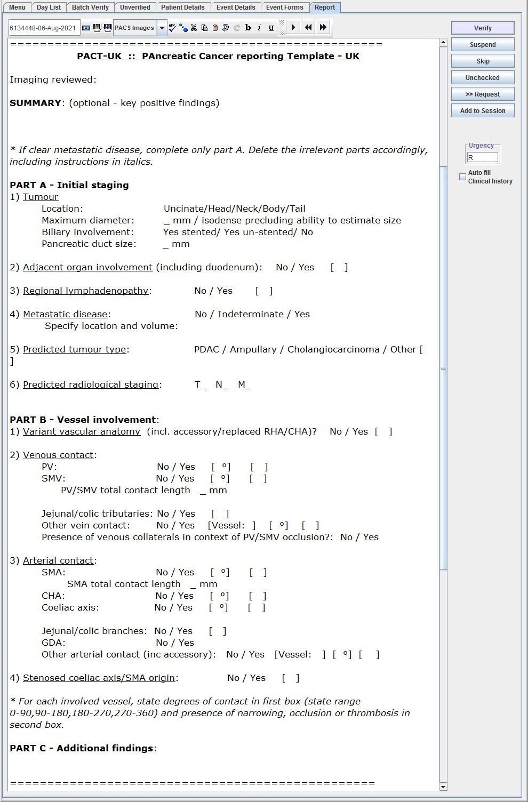

PACT-UK - Post Neoadj (CRIS version):

