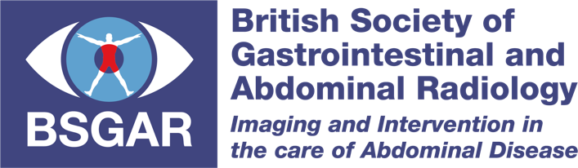

BSGAR Research Bursary 2023

The BSGAR Committee are pleased to invite applications for the Research Bursary – Spring 2023. The bursary value is up to £20,000 on this occasion and research projects must be related to the field of GI and abdominal radiology.

Applications should be emailed to office@bsgar.org, with supporting documentation, before the closing deadline of 31st March 2023. Applications should be accompanied by an up-to-date CV for the lead applicant and written agreement of the host department.

Please complete all sections of this application form. You may embed one figure within the project plan, but this should not be used to overcome the word limit.

The value and total numbers of bursaries will be decided at the discretion of the scoring sub-committee.

Queries can be directed to office@bsgar.org and will be answered as soon as possible. Potential applicants who do not currently work in a research active department, or do not have main supervisor in their department, are encouraged to contact office@bsgar.org to discuss their project proposals.

Project Title
Click or tap here to enter text.

Applicant Details
Surname
Click or tap here to enter text.
Other Names (in full)
Click or tap here to enter text.
Current Post
Click or tap here to enter text.
Name & Address of Host Organisation
Click or tap here to enter text.
E-mail address  Click or tap here to enter text. | Daytime Telephone Number  Click or tap here to enter text.
List any relevant previous research funding
Click or tap here to enter text.
Relevant publications (maximum of 5)
Click or tap here to enter text.

Main supervisor (or co-applicant if an experienced lead applicant)
Surname
Click or tap here to enter text.
Other Names (in full)
Click or tap here to enter text.
Current Post
Click or tap here to enter text.
Name & Address of Host Organisation
Click or tap here to enter text.
E-mail address  Click or tap here to enter text. | Daytime Telephone Number  Click or tap here to enter text.
List any relevant previous research funding
Click or tap here to enter text.
Relevant publications (maximum of 5)
Click or tap here to enter text.

Experience of research team in relation to project (maximum 500 words)
Click or tap here to enter text.

Plain English summary (maximum 300 words)
Please provide a clear explanation of your project so that those reviewing your application can easily understand your proposal without having specialist knowledge
Click or tap here to enter text.

Abstract (maximum 300 words)
Click or tap here to enter text.

Aims & Objectives
Click or tap here to enter text.

Background (maximum 500 words)
Click or tap here to enter text.

Project Plan (max 1,500 words)
The project plan must include the following sub-sections:
(Study design, Methods, Sample size, Data Collection, Analysis plan, Ethical considerations and approvals, Project timeline, Outcomes)

Text:
Click or tap here to enter text.

Figure:

Patient and public involvement (maximum 300 words)
Click or tap here to enter text.

Anticipated impact on patient care (maximum 300 words)
Click or tap here to enter text.

Funding requested (up to £20,000)
Click or tap here to enter text.

Breakdown and justification of costs
Click or tap here to enter text.

Details of any other funding sources sought or secured
Click or tap here to enter text.

References (one side of A4 only)
Click or tap here to enter text.

